PASSIVE SOLAR  John Perlin*, co-author [with Ken Butti] of A Golden Thread - 2500 Years of Solar Architecture and Technology, provides here a short summary of the evolution of passive solar design - Passive Solar refers to an approach to heating and cooling homes through simple devices and architectural design, as opposed to mechanically operated heating and cooling systems. | 
THE 5TH CENTURY
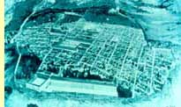
The ancient Greeks planned whole cities in Greece and Asia Minor such as Priene, shown in the illustration, to allow every homeowner access to sunlight during winter to warm their homes. By running the streets in a checkerboard pattern running east-west and north-south pattern every home could face south, permitting the winter sun to flow into the house throughout the day.
During the fifth century BC., the Greeks faced severe fuel shortages. Fortunately, an alternative source of energy was available - the sun. Archaeological evidence shows that a standard house plan evolved during the fifth century so that every house, whether rural or urban, could make maximum use of the sun's warm rays during winter. Those living in ancient Greece confirm what archaeologists have found. Aristotle noted, builders made sure to shelter the north side of the house to keep out the cold winter winds. And Socrates, who lived in a solar-heated house, observed, "In houses that look toward the south, the sun penetrates the portico in winter" which keeps the house heated in winter. The great playwright Aeschylus went so far as to assert that only primitives and barbarians "lacked knowledge of houses turned to face the winter sun, dwelling beneath the ground like swarming ants in sunless caves."

ANCIENT ROME
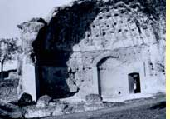
Cross section of a Roman heliocaminus. The term means "sun furnace." The Romans used the term to describe their south-facing rooms. They became much hotter in winter than similarly oriented Greek homes because the Romans covered their window spaces with mica or glass while the Greeks did not. Clear materials like mica or glass act as solar heat traps: they readily admit sunlight into a room but hold in the heat that accumulates inside. So the temperature inside a glazed window would rise well above what was possible in a Greek solar oriented home, making the heliocaminus truly a "sun furnace" when compared to its Greek counterpart.
Fuel consumption in ancient Rome was even more profligate than in Classical Greece. In architecture, the Romans remedied the problem in the same fashion as did the Greeks. Vitruvius, the preeminent Roman architectural writer of the 1st century BC., advised builders in the Italian peninsula, "Buildings should be thoroughly shut in rather than exposed toward the north, and the main portion should face the warmer south side." Varro, a contemporary of Vitruvius, verified that most houses of at least the Roman upper class followed Vitruvius' advice, stating, "What men of our day aim at is to have their winter rooms face the falling sun [southwest]." The Romans improved on Greek solar architecture by covering south-facing windows with clear materials such as mica or glass. They also passed sun-right laws that forbade other builders from blocking a solar-designed structure's access to the winter sun.

SOLAR GREENHOUSES
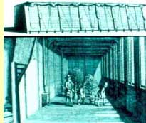
Like the ancient Romans, the 18th century Dutch and others in Europe at the time, used glass-covered south-facing greenhouses to capture solar heat in wintertime to keep their exotic plants warm. To prevent the solar heat captured during the day from escaping, the Dutch covered the glass at night with canvas coverings.
The ancient Romans not only used window coverings to hold in solar heat for their homes but also relied on such solar heat traps for horticulture so that plants would mature quicker, produce fruits and vegetables out of season, and allow for the cultivation at home of exotic plants from hotter climates. With the fall of the Roman Empire, so to came the collapse of glass for either buildings or greenhouses. Only with the revival of trade during the 16th century came renewed interest in growing in solar-heated greenhouses exotics brought back from the newly-discovered lands of the East Indies and the Americas. Trade also created expendable incomes that allowed the freedom to take up such genteel pursuits as horticulture once more.
Nineteenth-century architects such as Humphrey Repton brought the sunlit ambiance of the greenhouse right into the home by attaching it onto the south side of a living room or library. On sunny winter days the doors separating the greenhouse and the house were opened to allow the moist, sun-warmed air to freely circulate in the otherwise gloomy, chilly rooms. At night, the doors were shut to keep in as much solar heat as possible. By the late 1800s the country gentry had become so enamored of attached greenhouses that they became an important architectural fixture of rural estates.
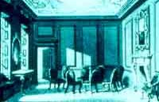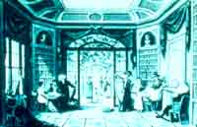
A 19th-century solar remodel: Architect Humphrey Repton turned a dull interior (left view) into a vibrant home by opening up the house to a south-facing greenhouse.
AMERICAN SOLAR HERITAGE
American solar architecture began with its indigenous heritage. Acoma, built by the Pueblo Indians in the 12th century AD and continuously inhabited since then., serves as an excellent example of their sensitivity to building with the climate in mind. The "Sky City," built atop a plateau, consists of three long rows of dwelling units running east to west. Each dwelling unit has two or three tiers stacked one behind the other as to allow each one full exposure to the winter sun. Most doors and windows open to the south to catch the warm solar rays of winter. The walls are built of adobe. The sun strikes these heat-absorbing south wall more directly in winter than during summer time. The sun's heat travels through the adobe slow enough to reach the interior as night falls, heating the house through the night. Insulating the ceiling with straw keeps the horizontal roof, vulnerable to the rays of the high summer sun, from allowing too much heat to enter the house.
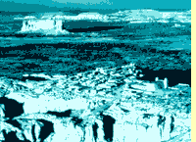
An Aerial view of the tiered rows of houses at Acoma
EARLY AMERICA
Spaniards who settled in the American southwest often built to take advantage of the winter sun : they aligned their homes east to west so the main portion of the house faced south. Shutters outside the windows were closed at night to help keep from escaping the solar heat that had flowed in all day during wintertime.
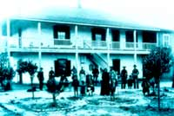
An early California family posing in front of the their Spanish-Colonial adobe house
Settlers in New England considered the climate when they built their homes. They often chose "saltbox" houses that faced toward the winter sun and away from the cold winds of winter. These structures had two south-facing windowed stories in front where most of the rooms were placed and only one story at the rear of the building. The long roof sloped steeply down from the high front to the lower back side, providing protection from the winter winds. Many saltbox houses had a lattice overhang protruding from the south facade above the doors and windows. Deciduous vines growing over the overhang afford shade in summer but dropped their leaves in winter, allowing sunlight to pass through and penetrate the house.
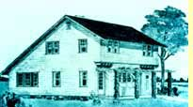
The colonial "salt box" house, typical of New England architecture of the 18th century.


The Royal Institute of British Architects developed in the early 1930s the device shown in this photograph called the heliodon to help architects determine the effects of the sun on buildings before they went up. By mounting a model of a proposed structure on a rotating drawing board below a fixed light source simulating the sun, designers could easily ascertain the solar exposure of the proposed building.
THE 20TH CENTURY
Ameliorating the terrible slums that blighted European cities during the industrial revolution sparked a renewed interest in building with the sun. As one English city planner bent on housing reform urged in the first decade of the twentieth century, "Every house should have its face turned to the sun, whence comes light, sweetness and health." Young architects on the Continent agreed, declaring that their profession should embrace functionalism over aesthetics. Functionality meant to many designing houses that satisfied the basic needs of those living in them. In the relatively chilly European climate this dictum meant providing dwellers with a warm haven. Therefore an architect wishing to build a useful house, Hannes Meyer, the leader of functional architecture in Germany, argued, must consider its body "to be a storage cell for the heat of the sun." Hence, "Maximal use of the sun," as far as Meyer was concerned, was "the best plan for construction." Meyer, who became the director of the highly famous and influential Bauhaus architectural school, told fellow architects that to achieve optimum sunshine in buildings, they must conduct or at least be privy to scientific research into the sun's year round movement relative to the Earth. Germany led a renaissance in solar building during the 1930s that spread throughout Europe only to be stamped out by the Nazis and then World War II.
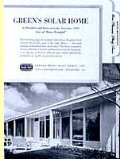
Advertisement for a prefabricated solar-oriented homeThe Nazis condemned functional architecture as Jewish and when they came to power, a good number of German architects designing solar buildings fled, many ending up in America. George Fred Keck, a Chicago architect, befriended some of these expatriates and through their influence began designing homes in the Chicago area according solar building principles - expansive south facing glass to trap the winter sun, long overhangs to shade the house in summer, minimal east-west exposure to prevent overheating in summer and fall, and the placement of secondary rooms, garages, and storage corridors on the north side to help insulate the living quarters from the cold north winds. Keck had a knack for publicity and called the houses he designed "solar homes." By the mid-forties Keck's work caught the attention of the national media. House Beautiful, Reader's Digest and Ladies Home Journal featured his work. Fuel rationing during the war inclined the American public toward valuing the energy saving features of solar homes. When war ended, the building market exploded. With the wartime-conservation ethic still imbued in most people's minds, many manufacturers in the prefabricated home industry adopted solar design features for leverage in this highly competitive market.
FINE TUNING SOLAR HOMES
Studies of houses with large amounts of glass on the south side demonstrated that they experience much greater temperature swings than ordinary homes, warming quickly during the day due to accumulating the sun's heat and cooling off rapidly at night due to large heat losses through the windows. Tucson Architect Arthur Brown did away with the unwanted fluctuations in temperature by running a thick black wall between the sun porch next to the south facing glass and the living quarters. During sunny winter days, sunlight struck the black wall and the concrete absorbed the solar heat. Estimating that heat moves through the wall at one inch an hour, Brown made the wall eight inches thick. As evening approached, the solar heat soaked up by the wall began to radiate into the rooms and continue to do so into the night. By morning all the solar heat in the wall had dissipated into the living areas, leaving the wall totally cooled down and ready for another heating cycle.
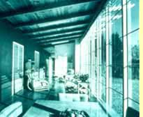
Interior view on a sunny winter day of the Tucson solar home designed by architect Arthur Brown. Sunlight streaming through the large expanse of south-facing window glass warms the masonry walls inside which pass the heat on to the living quarters after sundown.
SOLAR HEATING FOR THE PUBLIC
Tucson-based architect Arthur Brown, responsible for the solar-absorbing wall described previously, also designed in 1948 the world's first solar-heated public building. Since students attended class between 9 AM and 3 PM, Brown did not have to worry about storing solar energy since no one needed heat at night or in the very early morning. To keep costs down, he used the roofing supports to separate the space between the ceiling and the roof into channels. In this way, the roof itself served as the solar collector. The school's fan that had forced gas heated air through the building, now pushed air through the channels. The sun's energy heated the air and a second fan distributed that heat into the classrooms when needed. The solar system provided the school with 86% of its heat. But in 1958, with energy cheap and the school district decided to expand the campus, the authorities chose a gas-fired furnace instead. Cheap energy running highly reliable and easy to use heating and cooling systems led to an almost universal disinterest in solar design.
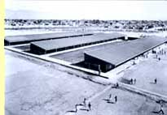
The solar-heated Rose Elementary School in Tucson Arizona. It obtained over 80% of its heat from solar energy for an entire decade, beginning in 1948.
THE 70'S AND BEYOND
Just as in ancient Greece, rising fuel costs in the 1970s forced many to turn to the sun again for help. The Village Homes subdivision's layout uncannily compares to the planning of solar cities in ancient Greece and Asia Minor. But as fuel prices dropped in the mid-1980s, people once more turned their backs from the sun. With electric and fuel prices again on the rise, history offers many lessons that can help smooth our transition to an enduring Solar Age.
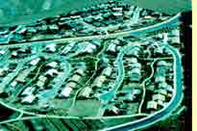
Aerial view of the Village Homes subdivision built in the late 1970s in Davis, California. The layout of the subdivision allowed every house to face the winter sun.
*John Perlin lives in Santa Barbara, California and can be contacted at Perlin@rahus.org

